# INTRODUCTION

* 1. **OVERVIEW**

Edu connect Language Connects’, a user-friendly English communication enhancement program, has been designed by a team of educational researchers from Edu comp Solutions Ltd. for the masses who wish to fulfill their dream of fluent communication in English. The bilingual approach used in ‘Educonnect Language Connects’ makes it a self-paced learning program that helps learners to relate the known (in their own language .

* 1. **PURPOSE**
  2. Educonnect is an innovative education-focused web application that is changing the way parents, students and educators discover, research and review schools and educational programs.

1. **Problem Definition & Design Thinking**
   1. **EMPATHY MAP**

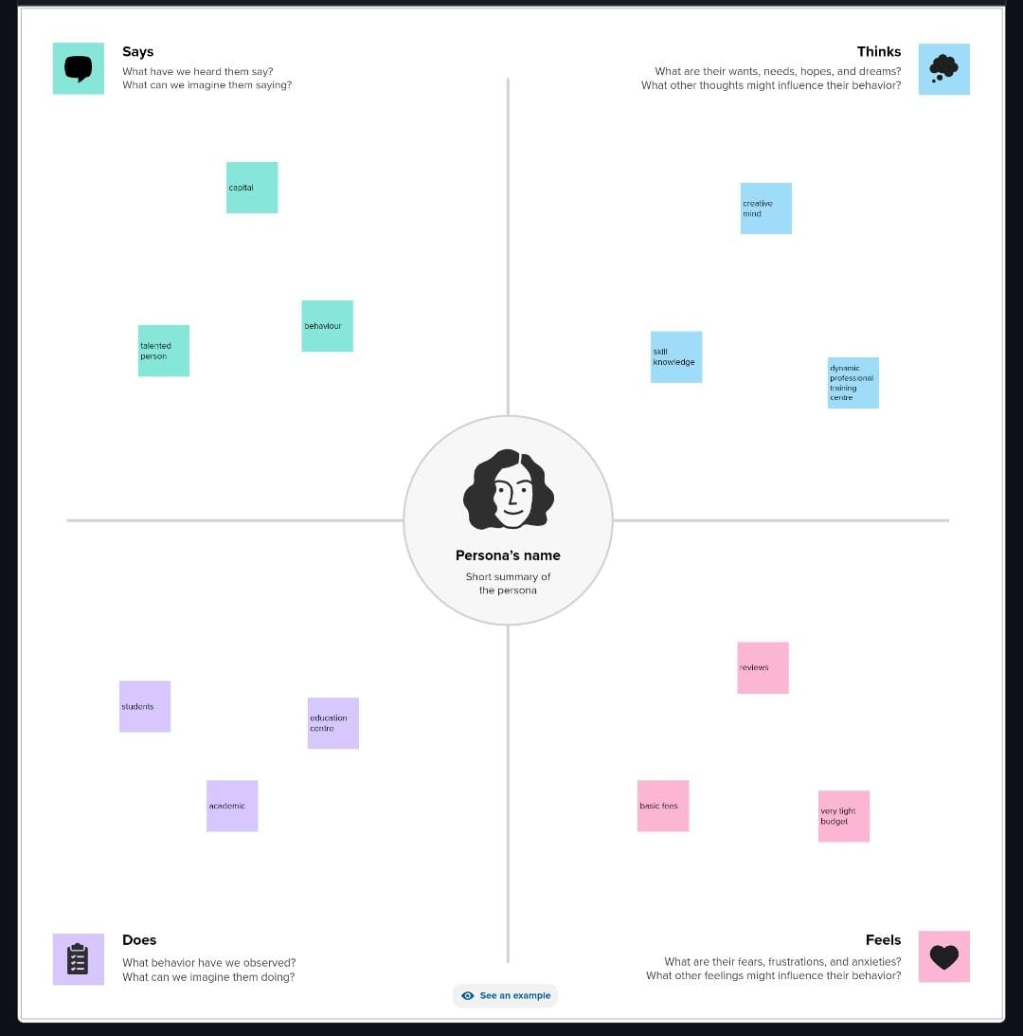

* 1. **BRAINSTORMING MAPPING**

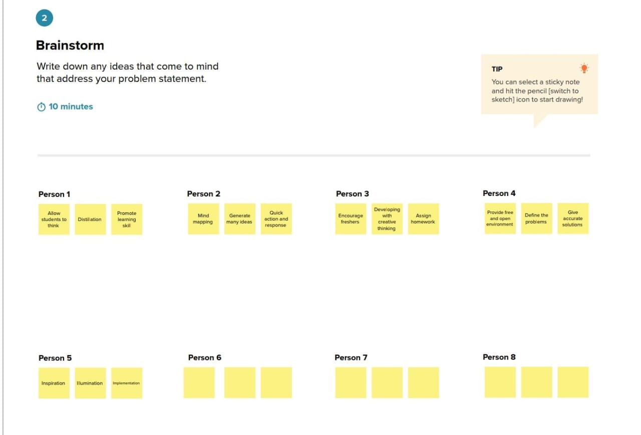

# RESULT

# dash.jpg

# 

# ADVANTAGES & DISADVANTAGES

# ADVANTAGES

* Discipline problems are reduced because groups are limited to a number which can reasonably function in each area.
* Classroom management is easier since children are in the area of their choice and interest.
* Children are engaged in hands-on activities as they explore and experiment.

**DISADVANTAGES**

* + - Distractions and lack of attention. ...
    - Excessive impact. ...
    - It reduces the development of other skills. ...
    - Consumption of false information. ...
    - Theft of personal data. ...
    - It reduces human contact. ...
    - It amplifies bullying

# APPLICATIONS

# Access to quality education is a fundamental right that should be available to all, regardless of their geographical location. In this pursuit, Project EduConnect stands as a shining example of how technology and community collaboration can bridge the education gap in rural areas.

# CONCLUSION

# All of these things together will make you successful in life. In conclusion, education makes you a better person and teaches you various skills. It enhances your intellect and the ability to make rational decisions. It enhances the individual growth of a person.

# FUTURE SCOPE

According to a report by Forbes, the e-learning market for higher education is expected to grow by 9.5% annually, reaching a market size of $325 billion by 2025.

**EDU CONNECT LEARNING CENTER**

